**LEGISLATIVE** **ASSEMEBLY** (**VIDHAN SABHA)-**

It is an institution /place where all the elected members from different constituencies of the state meet to discuss many important things. (ie. Elected Ruling party members and Opposition party members)

**FUNCTION**

1. **Function of Legislation** (It makes laws for the state on subjects or topic mentioned in the state list and the concurrent list of the constitution )
2. **Function of Representation** -it represents the views and needs of citizen. Members act on behalf of voters and citizens.
3. **Function of Scrutiny** --It examines the government work and policies and makes them accountable to people.
4. **Function of Formation of government-** The party that gets maximum seats in the assembly by winning their respective constituencies form the Government. Headed by a Chief Minister who selects his Council of Ministers .

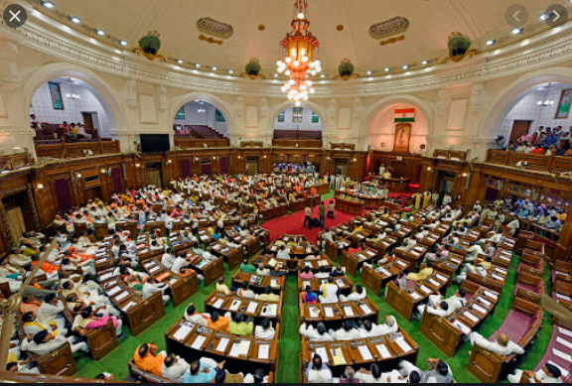 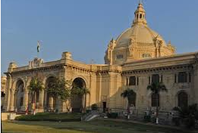

**GOVERNOR OF UTTAR PRADESH**

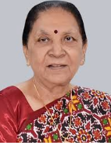 **Ms. Anandiben Patel**

**CHIEF MINISTER OF UTTAR PRADESH**

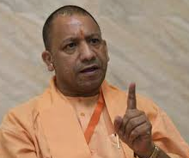 **Shri YogiAdityanath**